IBoss Instruction

IM&T Department

Modified by:

Version: 0.2

Update on: 18/03/2025 11:18

Location: Https://Lcwucc.Sharepoint.Com/Sites/Digitalgroup-Ibossmigrationproject/Shared Documents/Iboss Migration Project/Pre Project Documentation/Iboss Documentation.Docx

Table of Contents

1. Objectives 3

2. Glossary 3

1. Installation 3

2.1. iBoss: 3

2.2. Windows App: 18

2. Login 22

2.3. iBoss: 22

2.4. Windows App: 22

2.5. Launching LCW Desktop: 23

FAQs: 24

2.6. Read through out 24

2.7. LCW Desktop Error: 24

2.8. I can’t open the Iboss download: 24

2.9. How to Open “System Settings”: 25

2.10. Windows App not Downloading: 25

Versions 27

End-user documentation

# Objectives

The main objective of this document is to provide detailed processes and guidelines for setting up your new virtual desktop environment using iBoss and Windows App.

# Glossary

The below are a list of names and definitions used in this document.

* **iboss**: A necessary application required on your device to allow the Windows app to function
* **Windows App:** The Virtual Desktop connector that will be the replacement of Citrix

# Installation

## iBoss:

### Windows:

Step 1: Click on the Sharepoint link below or copy and paste it into the browser (Chrome, Microsoft edge etc..) of your choice.

<https://nhs.sharepoint.com/:f:/s/msteams_e2c891/EjmxeNNpYz5MshOiqfRipRsB5LDn-hMnpCkjumSRc3EoQA?e=t8V2wY>

Step 2: Login using your NHS email credentials

Step 3: click on the BYOD-Mandatory-6.5.195.0 file

Step 4: Press the download button.

Step 5: When it has finished downloading, press CTRL J to open your downloads and click on the newly downloaded application. If you are using Microsoft Edge and unable to download the file, please refer to section 2.8 and then continue following the steps.

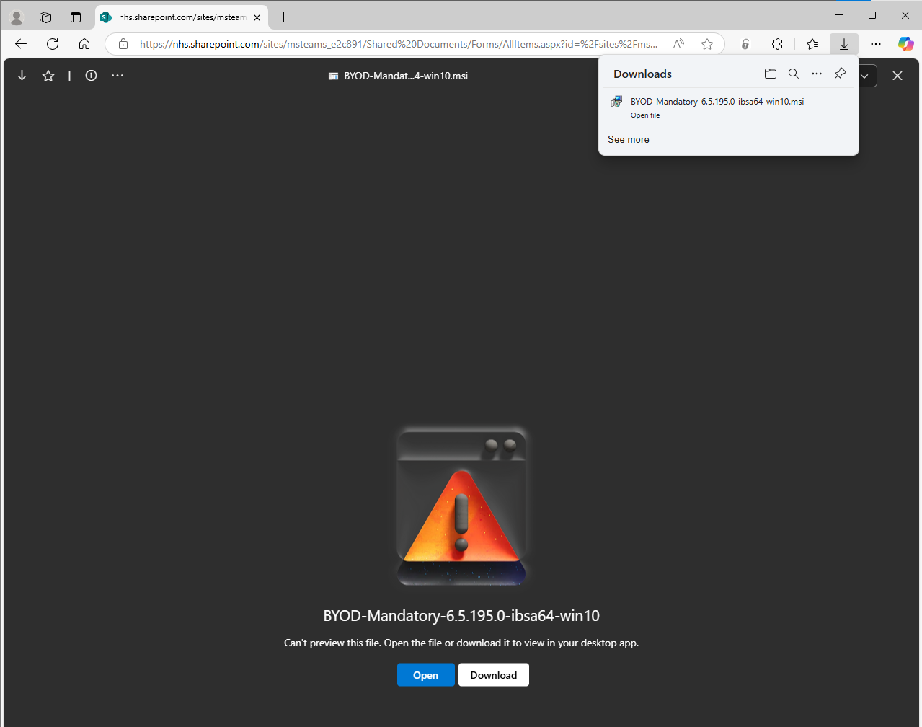

### MacOS:

Step 1: Click on the Sharepoint link below or copy and paste it into the browser (Chrome, Microsoft edge etc..) of your choice and login using your NHS Credentials.

<https://nhs.sharepoint.com/:f:/s/msteams_e2c891/EjmxeNNpYz5MshOiqfRipRsB5LDn-hMnpCkjumSRc3EoQA?e=t8V2wY>

Step 2: click on the BYOD-Mandatory-7.0.0.200 file and press on the Download button.

Step 3: Once the file is downloaded open the file, it will be in your “Finder” specifically in the “Downloads” on the right side as seen below. Simply double-click “iBoss-macOS-CC11-gen2.pkg” to open the installer.

Step 4: Click “Continue”   
computer” then click “Continue”

 Step 6: Click “Install”

Step 5: Authenticate via “Touch ID” or by clicking “Use Password” and using the password they use to log into their Mac. Their account must have administrator permissions on that machine.

Step 6: On the following popup click “Open System Settings”. If this notification doesn’t appear for you then do not worry and go to step 9.

Step 7: Click the toggle next to “iboss macOS Cloud Connector Utility” to turn it on.

Step 8: Authenticate via “Touch ID” or by clicking “Use Password” and using the password you used to log into your Mac.

Step 9: Click “Close” to exit the installer

Step 10: Now we need to install the MacOS VPN profile. To do this go to the extracted folder from earlier and open “iboss-macOS-CC11-gen2.mobileconfig”.

Step 11: The following popup will appear. Dismiss it by clicking OK.

Step 12: Open “System Settings”, and click on “General” in the sidebar, then click on “Device Management”. If Device Management does not appear for you then click on “Search” and write “Profiles”. Click on Profiles when the options comes up in your search and if it looks like what you see in Step 13 you are at the right place.

Step 13: Under the “Downloaded” heading, click on “iboss macOS Cloud Connector”.

Step 14: Click on “Install”.

Step 15: Click on “Install”

Step 16: Enter the Username and Password of an Administrator on the local machine. 

Step 17: Once installed the green iboss icon will be displayed in the MacOS toolbar.   


## Windows App:

### Windows:

Step 1: Click on the link below or copy and paste it into the browser (Chrome, Microsoft edge etc..) of your choice

<https://apps.microsoft.com/detail/9N1F85V9T8BN?hl=en-us&gl=GB&ocid=pdpshare>

Step 2: Click on the Download button.

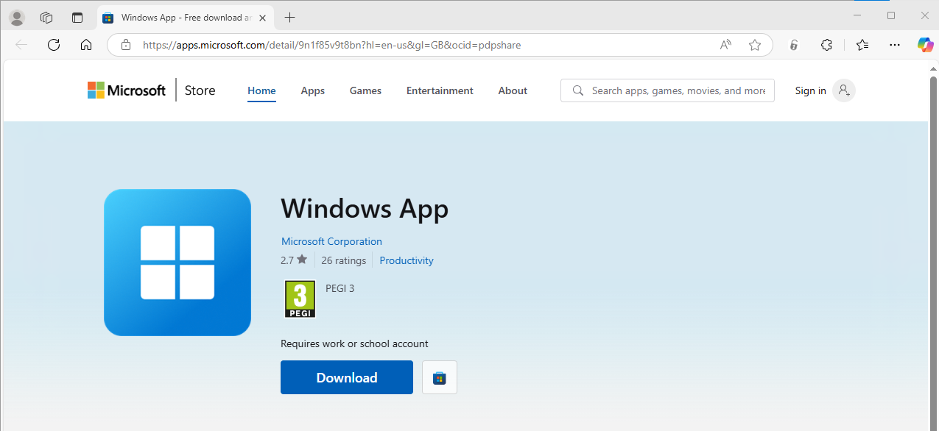

Step 3: When it has finished downloading, press CTRL J to open your downloads and click on the newly downloaded application.

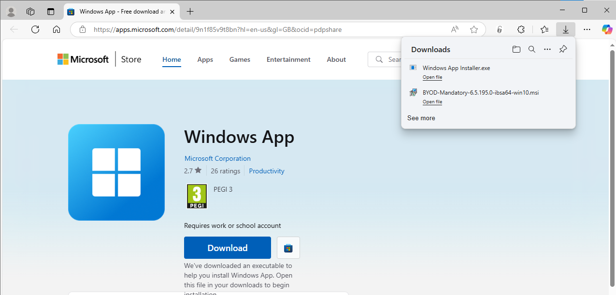

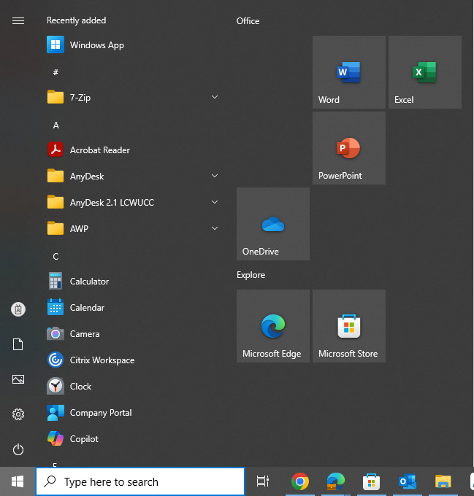Step 4: Open the Windows App on your device. It will be on to your “recently added” when pressing on the windows button at the bottom left of your screen.

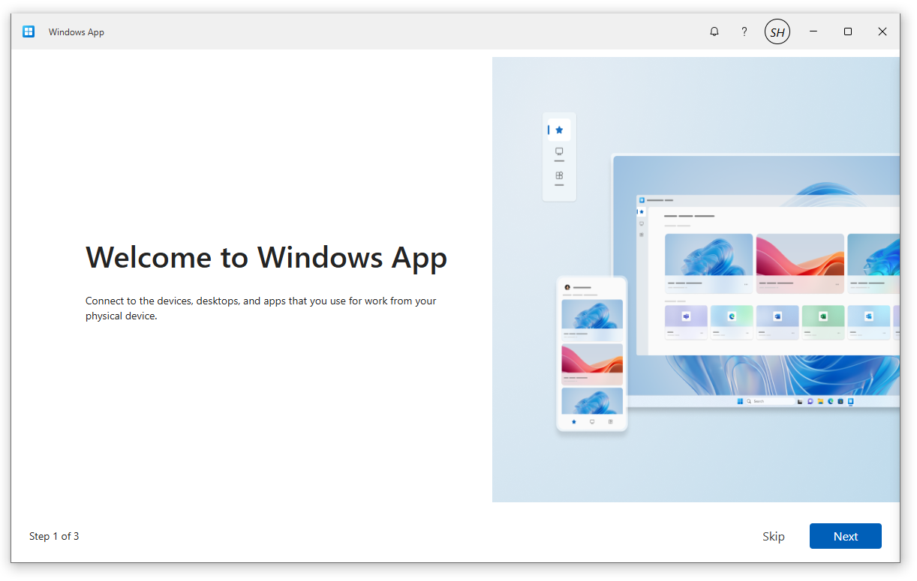Step 5: Once you open the windows app for the first time you will be greeted with this welcome message, just press “skip”.

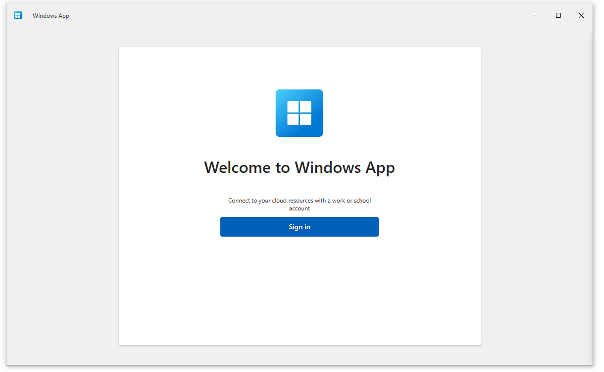Step 6: Press Sign in

Step 7: Login using your LCW Windows/Citrix credentials and you will be met by the following screen. If you press on “Connect” it will open the virtual desktop, and you can work as you would previously.

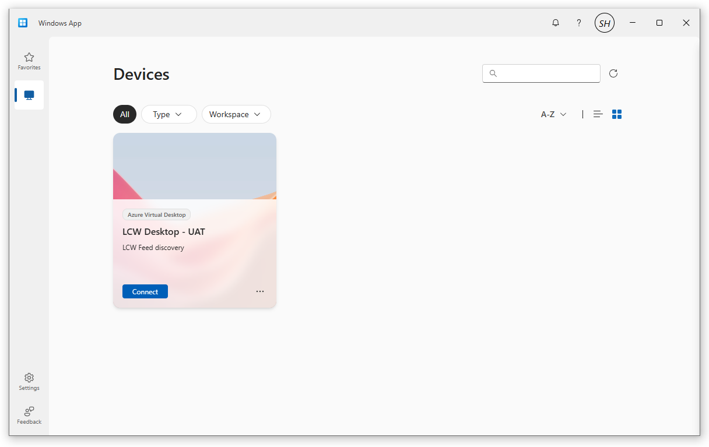

### MacOS:

Step 1: Click on the link below or copy and paste it into the browser (Chrome, Microsoft edge etc..) of your choice

<https://apps.apple.com/gb/app/windows-app/id1295203466?mt=12>

Step 2: Click on the Download button.



Step 3: Open the Windows App on your device and press skip.

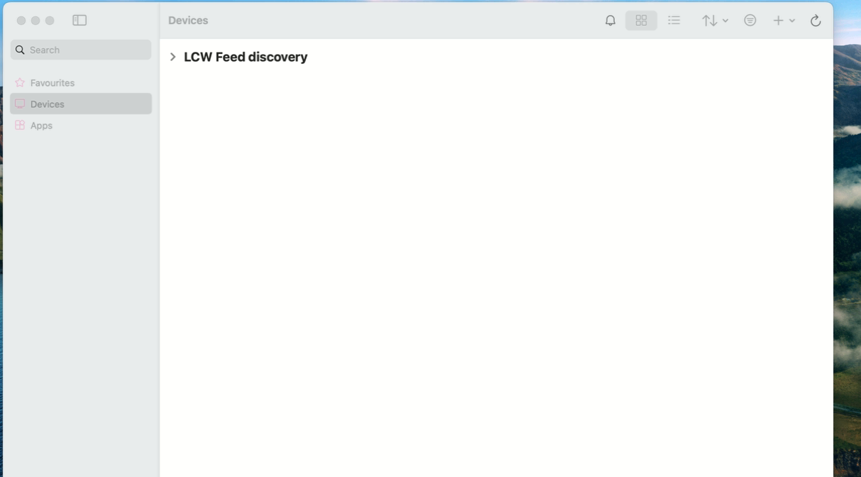Step 4: Once you click Skip you will be shown this page on the Windows App

Step 5: Click on the plus button at the top right of the windows app then click on “Add Work or School Account”

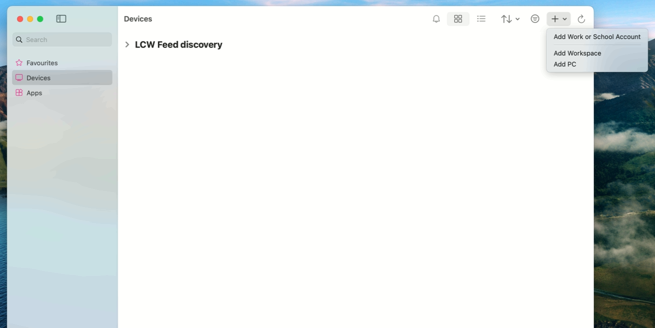

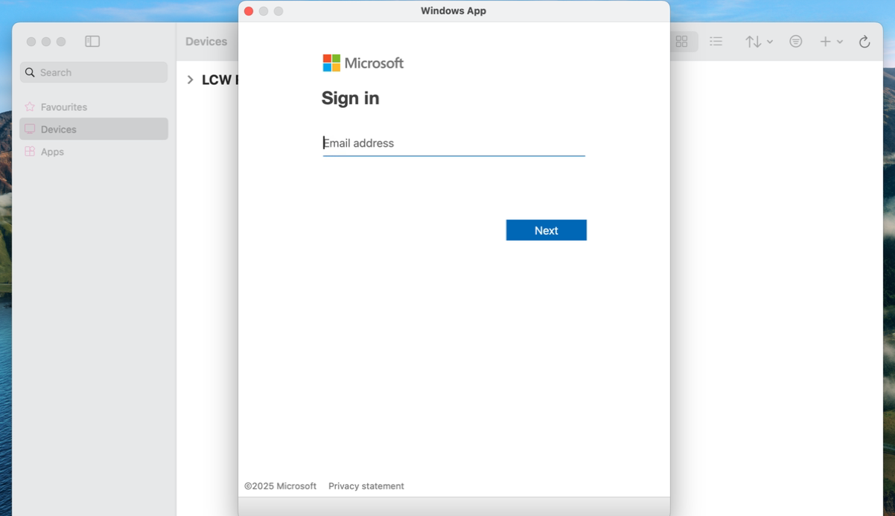Step 6: Sign in with your LCW Account (Citrix Logins)

Step 7: This is what you will when you have successfully signed in. Click on LCW Desktop - UAT to access the remote desktop and you can now work as usual.

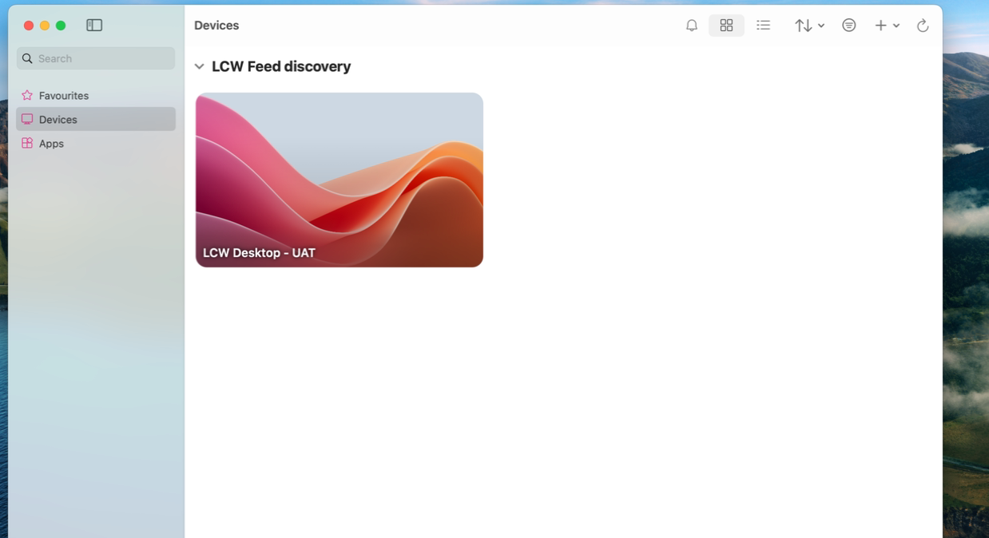

# Login

## iBoss:

Step 1: Open the iBoss app, it will be on to your “recently added” when pressing on the windows button at the bottom left of your screen.  
  
Step 2: Login using your LCW Windows/Citrix credentials. These logins are identical to your Citrix login details.

## Windows App:

Step 1: Press Sign in

Step 2: Login using your LCW Windows/Citrix credentials and you will be met by the following screen.



## Launching LCW Desktop:

Step 1: Press on “Connect” it will open the virtual desktop, and you can work as you would on Citrix.

# FAQs:

## Read through out

Before actioning any process, please read through the whole process first.

## LCW Desktop Error:

If you see this error below, then you need to make sure your login details are correct and they are identical to your Citrix logins (name.surname@lcw.nhs.uk).

## I can’t open the iBoss download:

On Microsoft Edge if you get a notification stating, “Make sure you trust BYOD-Mandatory-6.5195.0-ibsa64-win10”, then put your mouse on the file, click on the 3 little dots and press “Keep” and then “Keep anyway

## How to Open “System Settings”:

On Microsoft Edge if you get a notification stating, “Make sure you trust BYOD-Mandatory-6.5195.0-ibsa64-win10”, then put your mouse on the file, click on the 3 little dots and press “Keep” and then “Keep anyway

## Windows App not Downloading:

When downloading the Windows App if you get this notification, it means you need to download the app through the Microsoft Store.

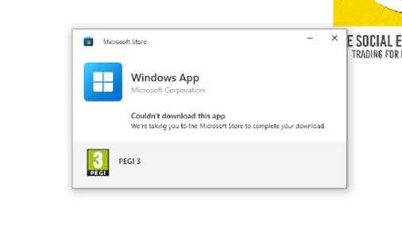

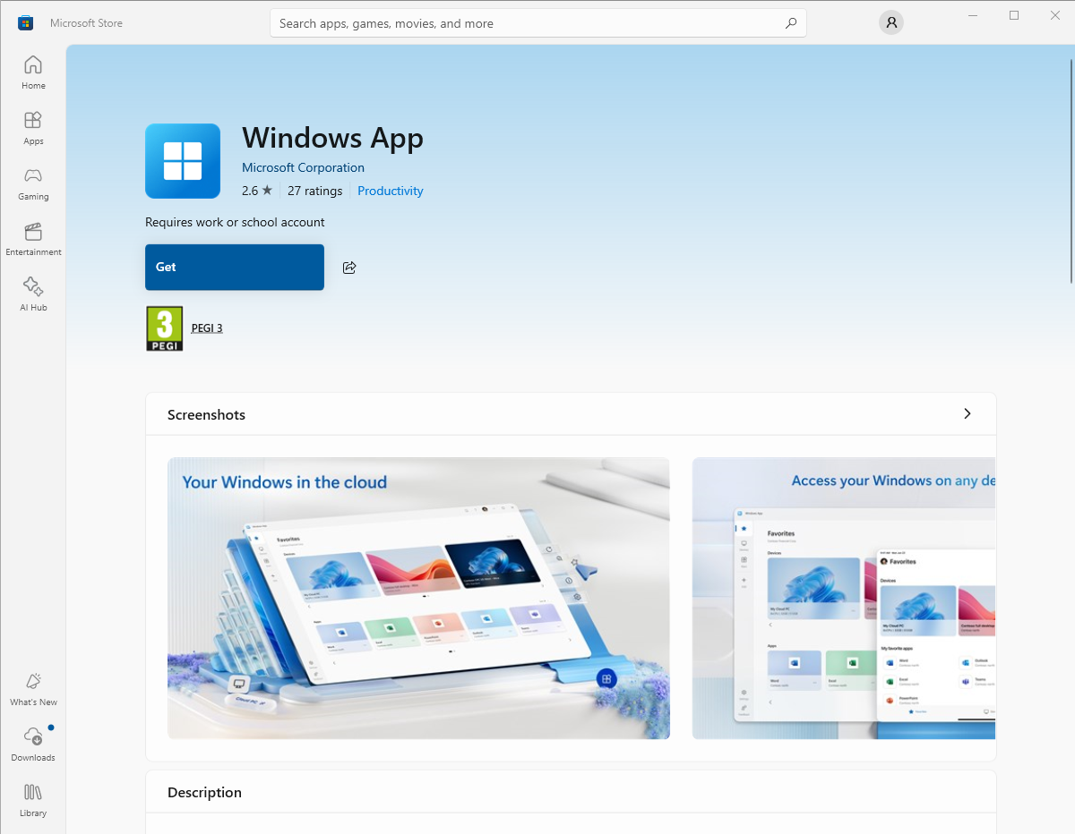It should automatically open the Microsoft Store but if it doesn’t simply search for the “Windows App” in Microsoft Store and press the “Get” button.

# Versions

|  |  |  |  |
| --- | --- | --- | --- |
| V | CHANGES DONE BY | DATE | COMMENTS |
| 0.1 | MANUEL ADAN GUTIERREZ | 18/03/2025 | First version of the document |
| 0.2 | Syed Hashemi | 23/04/2025 | Methodology written out with diagrams |